Chapter 17, Solution 5.

Obtain the Fourier series expansion for the waveform shown in Fig. 17.49.

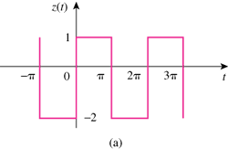

2

–4

Figure 17.49
For Prob. 17.5.

Solution

Thus,

